**LAPORAN PRAKTIKUM PEMROGRAMAN BERORIENTASI OBJEK**

“Nested Class*”*

**

**Anavalis Ridho Abdee Nugroho**

**4523210012**

Dosen Pembimbing :

**Adi Wahyu Pribadi, S.Si., M.Kom.**

**FAKULTAS TEKNIK**

**UNIVERSITAS PANCASILA**

**JAKARTA**

**2024**

1. **Source app**

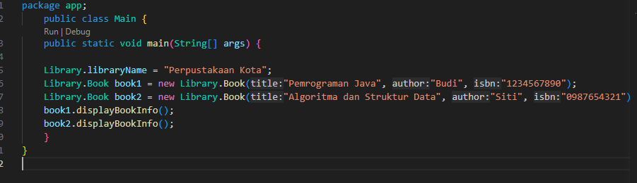

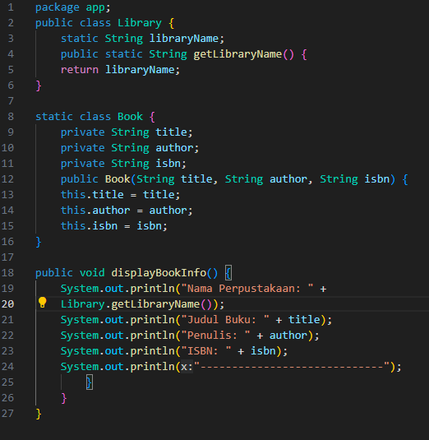

Output

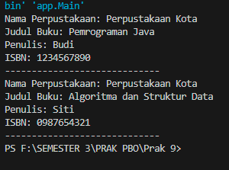

1. **Source Code Sistem Atm**

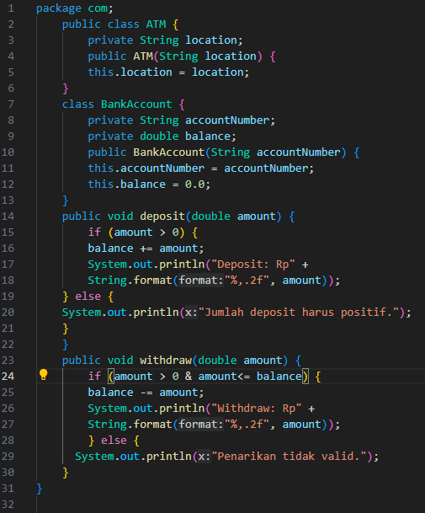

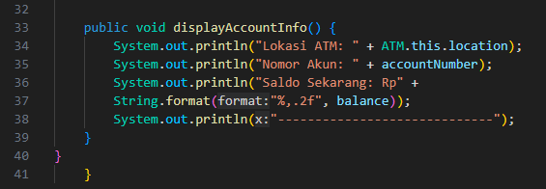

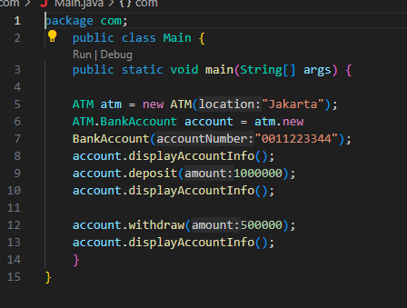

Output

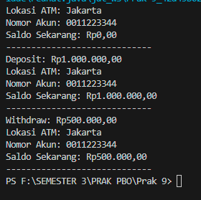

1. **Source Code timer sederhana**

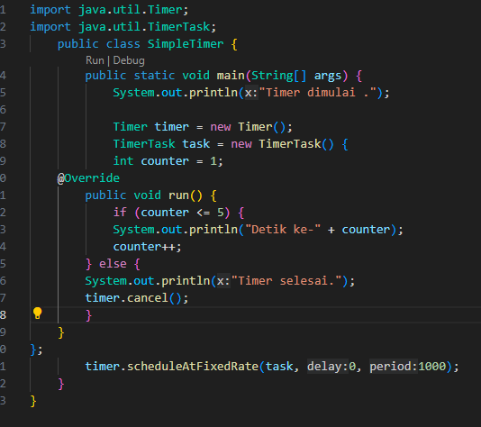

**Output**

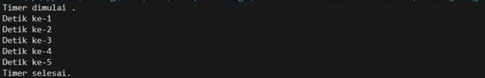

1. **Source FacorialCalculator**

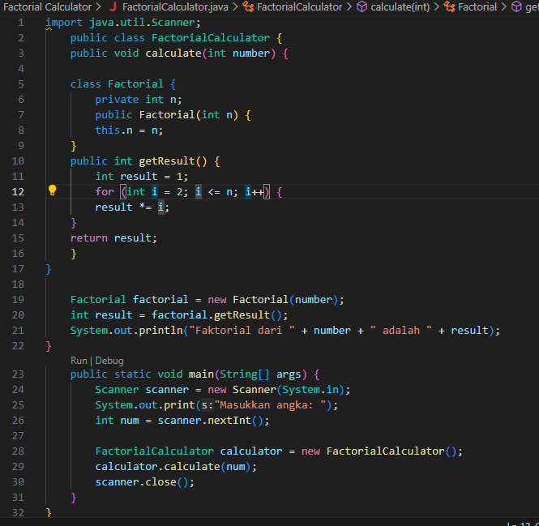

Output

